Template – Change of Grade Form Sequence
The template named “Template – Change of Grade Form Sequence” is applicable to Anthology Student.

Purpose and Outcome
This template provides a form sequence and supporting workflow for a form sequence to be completed by staff members to change a student’s grade and digitally sign the Change of Grade form.
The sequence requires the following:
- A complete Staff record must exist in the Anthology Student database.
- The staff member must have Staff credentials to log into this authenticated sequence.
The workflow looks up the Staff, Student, Course, and Enrollment entities, updates the student’s grade and generates a PDF of the completed Change of Grade form.

Prerequisites
The template was built with Forms Builder using the applications listed below. The template is forward compatible with later versions of the listed applications.
Application | Compatibility Version
Forms Builder Designer and Renderer | Compatibility Matrix
Web Client for Anthology Student
Workflow Composer
Packages installed from Package Manager in Workflow Composer | Activities and Contracts (V2)  Contracts (V1)  Forms Builder Contracts  Note: Ensure that the Forms Builder Contracts package used in Workflow Composer is aligned with the version used in the Forms Builder. Additionally, confirm that both Activities and Contracts (V1) and Activities and Contracts (V2) packages in Workflow Composer match the versions used in the Student Web Client to avoid compatibility issues.  It depends on which product is being used, for example:  For CRM:  Activities And Contracts (CRM)  Forms Builder Contracts
Workflow Tracking Database | N/A
Staff STS | 3.3.x

Step 1: Download and Import the Template
- Download the template file to your environment (local drive or network location).
- Log into Forms Builder Designer.
- Click the Export/Import tile.
- Select the Import tab.
- Click Select exported file and navigate to the downloaded template file.
- Click Import.
Note: Import may fail if same files name is already available in environment or overwrite option.

- Export/Import
The following forms will be imported:
- Grade Change Form
- View Summary
- Custom - Confirmation Standard No Auto Close

Step 2: In Form Designer…
- From the Forms slide out, select the Grade Change Form.
- Customize the form for your environment. Modify properties on fields/components to make them required, etc., or add/remove fields on form.
Make sure you edit the text in the Labels and HTML controls as applicable for your institution.
- Fields and Components
- Save the form.
- Repeat steps 1-3 for the View Summary and Custom - Confirmation Standard No Auto Close forms.

Step 3: In Sequence Designer…
- Locate the Change of Grade Form Sequence in the Sequences pane.
- Click Save As to create a copy of the sequence/workflow and customize the copy for your use. This way you can always refer to the original sequence/workflow you downloaded.
- Optional - Add a custom style (theme) associated with your campus.
- Themes
- Select your saved sequence in the Sequences pane.
- In the Properties Pane, select End State Form “Custom - Confirmation Standard No Auto Close”.
- Save the sequence.

Step 4: In Workflow Composer…
- Open the workflow for your saved sequence.
- Opening Workflows for Sequences
- Explore the arguments, states, and transitions to get an understanding of the workflow logic.
- In the Submit transition, locate the ExecuteODataQuery<StudentCourseEntity> activity and edit the host name for your Anthology Student environment.
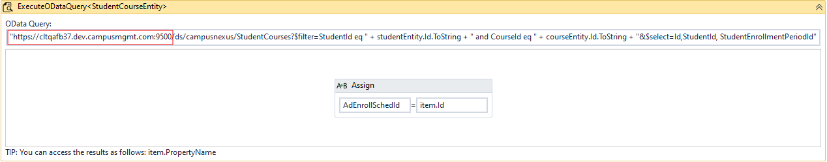
Note: If you are using Anthology Student 21.2 and later, the ExecuteODataQuery<> activity requires the APIUser to have access to any of the entities referenced in the query. See https://help.anthology.com/wf/Content/Workflow/ODataAuthorization.htm
- Further down in the Submit transition, in CreateDocument activity, set DocumentType and DocumentStatus to correct values for your environment (OnFile is recommented for DocStatus).
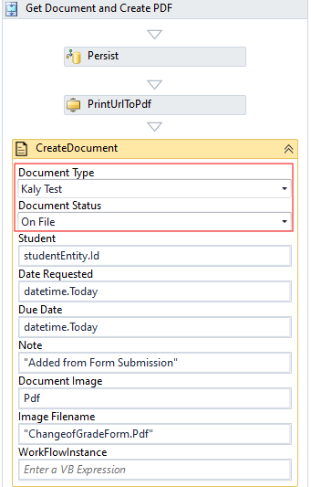

Step 5: In Forms Renderer…
Select your sequence and try it out!
- Sequence List
- Find your Change of Grade Form Sequence and copy the URL to the clipboard.
- Paste the URL into a browser and complete the form sequence.
- In Anthology Student, verify that the staff member’s address information is updated as specified in the form sequence.

Step 6: Lastly…
Once your updated sequence has been tested successfully, it is recommended that you disable the workflow for the original Template version.
- In Workflow Composer, in the Server section of the ribbon, click Open.
- Find the workflow named Change of Grade Form Sequence.
- Clear the Enabled check box and click Save.

